Guidelines
- Kindly use the given template for submitting your project (Make a copy of the template)

- One team is only required to submit one project/ppt.
- The ideal size of the presentation should not be more than 10 slides.
- You are welcome to add as many POCs and design concepts to support your project.
- The project should be feasible and the team members should be capable enough, to come up with the prototype of the same idea, if required.
- Solutions must include at least one Google technology.
Team Details

  - Team name: CYBER KNIGHT
  - Team leader name: NALIN KUMAR . S
  - Problem Statement: Open Innovation
In critical environments such as hospitals, industrial areas, smart cities, wildlife zones, and public safety systems, sudden abnormal sound events (accidents, distress calls, machine failures, intrusions) are often missed or detected late. Traditional surveillance systems rely on continuous video recording, which results in high power consumption, excessive storage usage, unnecessary data processing, and delayed response time. These systems lack intelligence to identify when an actual event occurs.
To address this challenge, QuiteScan introduces an intelligent sound-activated burst imaging solution. Instead of continuously recording visuals, the system constantly monitors audio signals and uses sound as the primary trigger. When predefined or abnormal sound patterns are detected, the camera is instantly activated to capture high-quality images or short image bursts of the event.
This approach significantly reduces energy usage and data redundancy, while ensuring important incidents are captured in real time. By combining sound detection with selective imaging, QuiteScan delivers faster response, improved monitoring accuracy, and cost-efficient operation. The system is especially useful in environments where silence is normal and sound indicates a possible issue.
In simple terms, QuiteScan listens first and captures visuals only when something important happens, making it a smart, efficient, and scalable solution for modern monitoring challenges

  - How different is it from any of the other existing ideas?

QuiteScan is different from existing surveillance systems because it uses sound as the primary trigger instead of continuous video recording or motion detection. Most current solutions continuously process visual data, leading to high power consumption, large storage requirements, and false alerts. QuiteScan stays in a low-power listening mode and activates imaging only when abnormal or meaningful sounds are detected, making it more energy-efficient, cost-effective, and capable of identifying incidents even when there is no visible movement.

b.How will it be able to solve the problem?

QuiteScan solves the problem by capturing visual evidence only at the exact moment an important sound event occurs. This eliminates unnecessary recording while ensuring critical incidents are not missed. By combining intelligent audio detection with burst imaging, the system reduces data overload, improves response time, and provides accurate situational awareness, making it highly effective for applications such as healthcare monitoring, industrial safety, security systems, and smart cities.

List of features offered by the solution

- Sound-Activated Imaging – Triggers camera capture only when abnormal or predefined sounds are detected
- Low-Power Listening Mode – Conserves energy by avoiding continuous video recording
- Burst Image Capture – Captures high-quality images or short image bursts at the exact moment of an event
- Reduced Data Storage – Stores only relevant event data, minimizing memory usage
- Fast Event Detection & Response – Enables quick identification of incidents in real time
- Noise Pattern Recognition – Differentiates normal background sounds from critical events
- Minimal False Alerts – Avoids motion-based false triggers
- Scalable & Flexible Deployment – Suitable for hospitals, industries, smart cities, wildlife monitoring, and security systems
- Cost-Efficient Operation – Lower power and storage requirements reduce overall system cost
Google Technologies used in the solution

- Google Cloud Speech-to-Text / Audio AI – Used to detect and analyze abnormal or predefined sound patterns
- TensorFlow / TensorFlow Lite – For training and deploying sound classification and noise recognition models
- Google Firebase – Real-time database and alerts for event notifications and logs
- Google Cloud Functions – Executes backend logic when sound-triggered events occur
- Google Cloud Storage – Stores captured images and event data securely
- Google Cloud IoT Core – Manages and connects sound sensors and camera devices
- Google Cloud Vision API – Analyzes captured images for object or incident recognition
- Google BigQuery – Stores and analyzes historical event data for insights and improvements
Process flow diagram or Use-case diagram
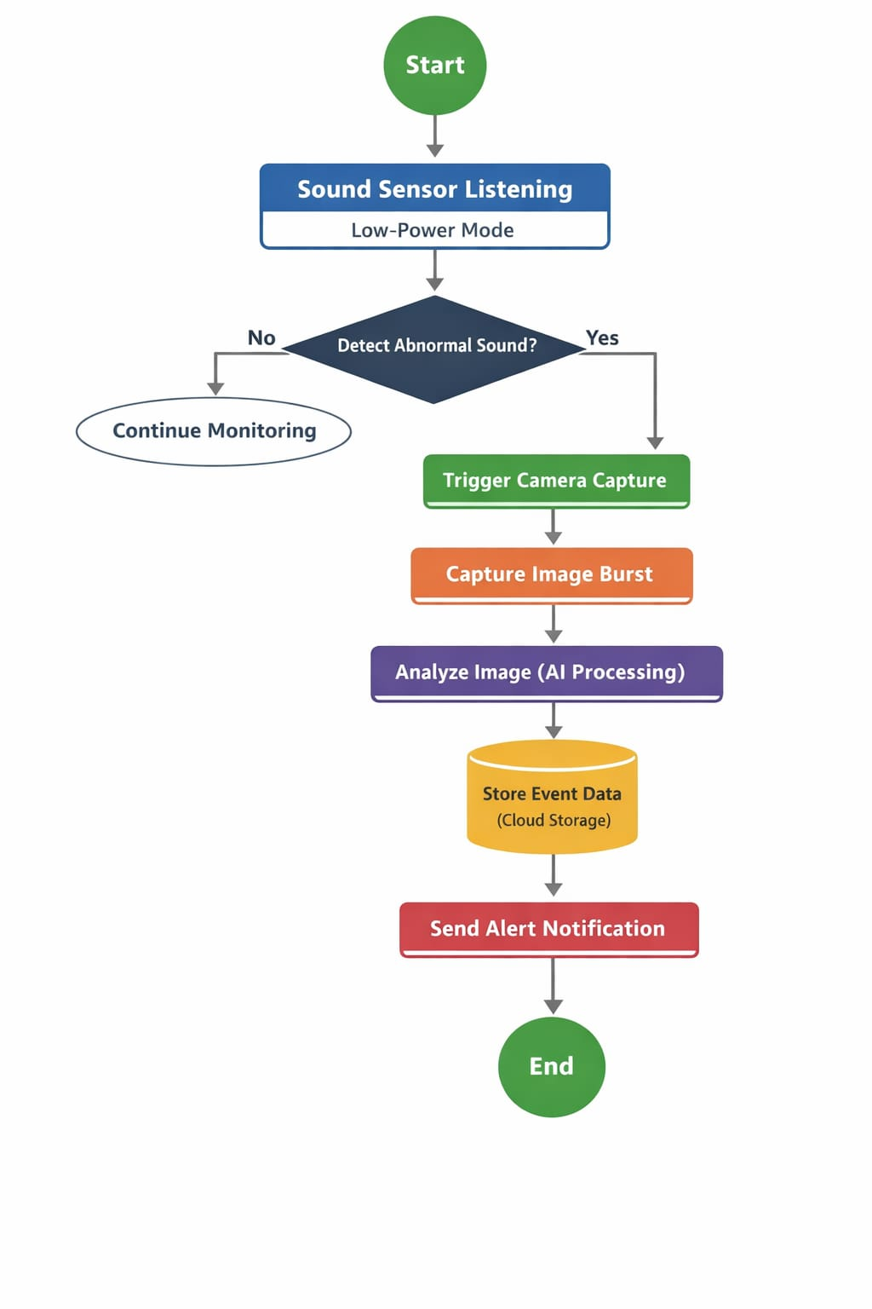
Wireframes/Mock diagrams of the proposed solution (optional)
- Advanced Sound Classification – Train AI models to recognize specific sound types such as distress calls, machine faults, alarms, or intrusions for higher accuracy.
- Edge AI Processing – Move sound analysis and initial decision-making to edge devices to reduce latency and internet dependency.
- Video Burst Extension – Upgrade from image bursts to short video bursts for richer visual context during critical events.
- Mobile & Web Dashboard – Develop a real-time dashboard for live alerts, event history, and system health monitoring.
- Multi-Sensor Integration – Combine sound detection with motion, vibration, or thermal sensors to further reduce false triggers.
- Scalability & Smart City Deployment – Expand the system for large-scale deployment across smart cities, industries, hospitals, and wildlife zones.
- Predictive Analytics – Use historical data to predict potential incidents and trigger preventive alerts.
- Custom Alert Rules – Allow users to define thresholds, sound profiles, and priority levels for alerts.
Architecture diagram of the proposed solution
Snapshots of the MVP
- Sound Detection Interface
- Shows the system actively listening in low-power mode
- Real-time sound intensity graph for abnormal sound detection
- Camera Trigger Snapshot
- Captures high-resolution burst images immediately after sound detection
- Includes timestamp and event ID for reference
- AI Analysis Dashboard
- Displays sound classification results (normal vs abnormal)
- Shows captured images and alert status
- Cloud Storage & Alert Panel
- Visual representation of images stored in the cloud
- Sends notifications to user devices via dashboard or app
- End-to-End Event Flow
- From sound detection → image capture → AI analysis → cloud storage → user alert
Additional Details/Future Development (if any)
- Advanced Sound Classification – Train AI models to recognize specific sound types such as distress calls , machine faults, alarms, or intrusions for higher accuracy.
- Edge AI Processing – Move sound analysis and initial decision-making to edge devices to reduce latency and internet dependency.
- Video Burst Extension – Upgrade from image bursts to short video bursts for richer visual context during critical events.
- Mobile & Web Dashboard – Develop a real-time dashboard for live alerts, event history, and system health monitoring.
- Multi-Sensor Integration – Combine sound detection with motion, vibration, or thermal sensors to further reduce false triggers.
- Scalability & Smart City Deployment – Expand the system for large-scale deployment across smart cities, industries, hospitals, and wildlife zones.
- Predictive Analytics – Use historical data to predict potential incidents and trigger preventive alerts.
- Custom Alert Rules – Allow users to define thresholds, sound profiles, and priority levels for alerts.

Provide links to your:
- GitHub Public Repository
https://github.com/nalinkumarsnalinkumars-1718
https://github.com/Monish172006
https://github.com/aravinthan27012007-ui
https://github.com/dhayanithithangaraj-collab

- Demo Video Link (3 Minutes)
- MVP Link
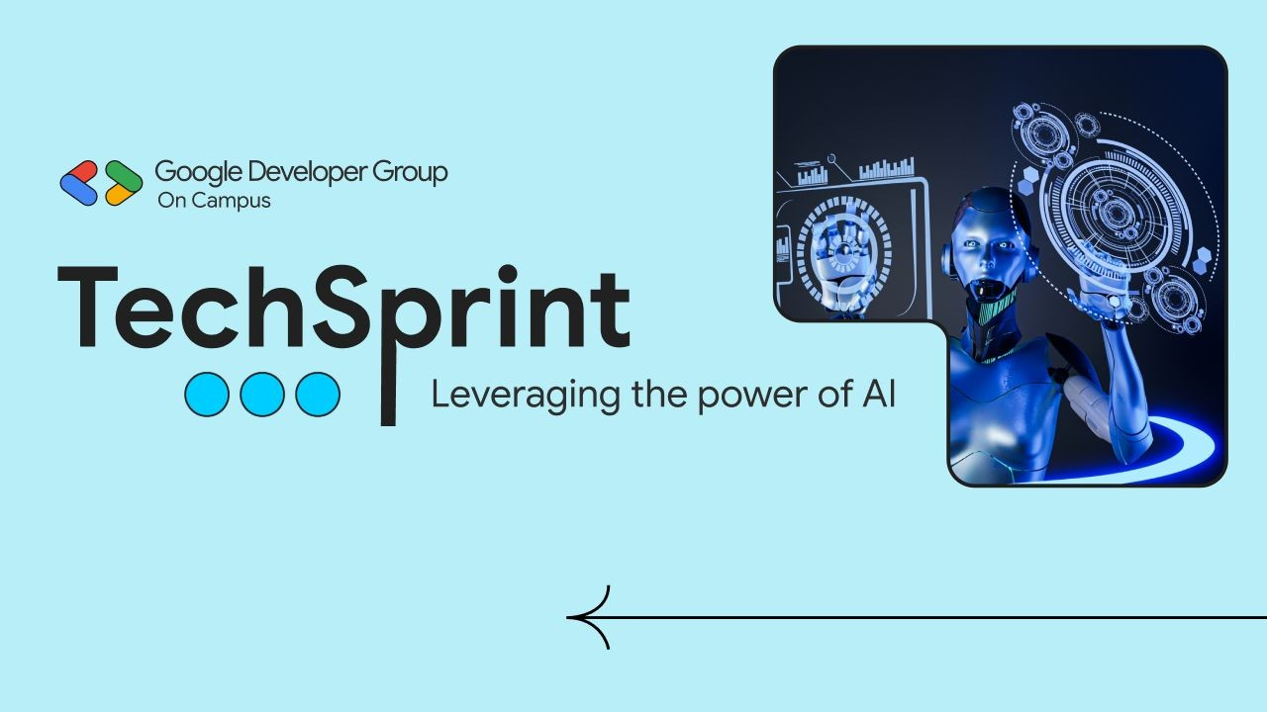
Thank you!

